**PSUC Lab Assignment**

**Lab 4:**

**Q1**) Generate the multiplication table for ‘n’numbers up to ‘k’ terms (using nestedfor loops).

**Code**:

#include<stdio.h>

int main()

{

int n,k,prod;

int i,j;

printf("The number of rows\n");

scanf("%d",&n);

printf("the number of coloumns\n");

scanf("%d",&k);

for(i=1;i<=k;i++)

{

for(j=1;j<=n;j++)

{

prod=i*j;

printf("%d*%d=%d\t",j,i,prod);

}

printf("\n");

}

printf("\nMy name is Saksham\n");

return 0;

}

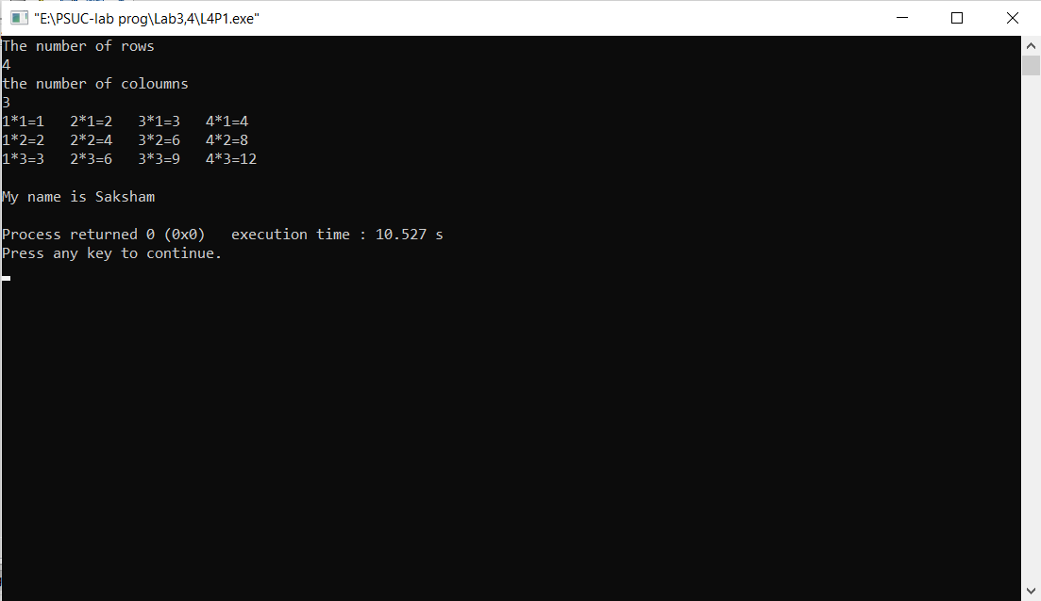**Output**:

**Q2**) Generate Floyd’s triangle using natural numbers for a given limit N. (using for loops)

**Code**:

#include <stdio.h>

int main()

{

int rows, i, j, number = 1;

printf("Enter the number of rows: ");

scanf("%d", &rows);

for (i = 1; i <= rows; i++)

{

for (j = 1; j <= i; ++j)

{

printf("%d ", number);

++number;

}

printf("\n");

}

printf("My name is Saksham");

return 0;

}

**Output**:

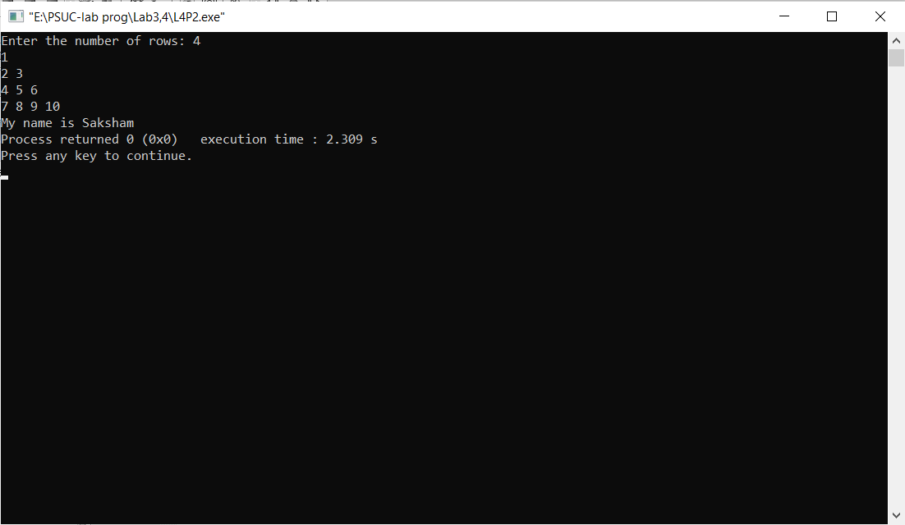

**Q3**) Evaluate the sine series, sin(x)= x-x3/3! + x5/5!–x7/7!+ ......... to n terms.

**Code**:

int main()

{

float n,no,sum,term;

float x;

int i;

printf("Enter the number of terms\n");

scanf("%f",&n);

printf("Enter the angle\n");

scanf("%f",&x);

no=x;

x=x*(3.14/180);

term=x;

sum=x;

for(i=1;i<=n;i++)

{

term = term*(((-1)*pow(x,2))/(2*i*(2*(i)+1)));

sum+=term;

}

printf("Library value of Sin(%.2f) = %.2f ", no, sin(x));

printf("\nSin (%.2f) = %.2f", no, sum);

printf("\nMy name is Saksham");

return 0;

}

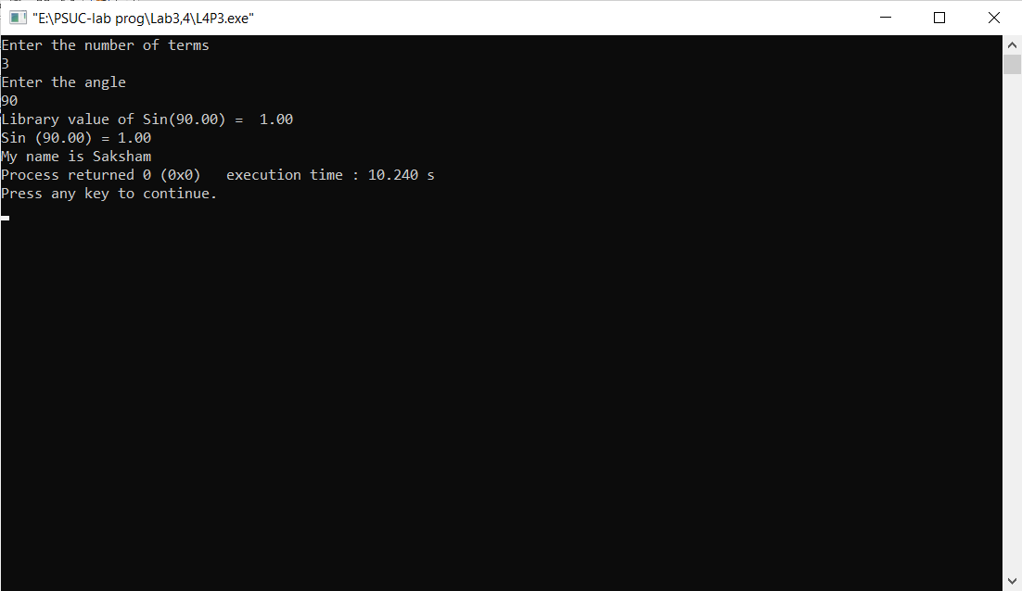**Output**:

**Q4**) Check whether a given number is perfect or not.

**Code**:

#include<stdio.h>

int main()

{

int num,sum=0,copy;

int i;

printf("Enter a Number\n");

scanf("%d",&num);

copy=num;

for(i=1;i<=num/2;i++)

{

if(num%i==0)

sum+=i;

}

if(sum==num)

printf("%d is a perfect number\n",copy);

else

printf("%d is not a perfect number\n",copy);

printf("My name is Saksham\n");

return 0;

}

**Output**:

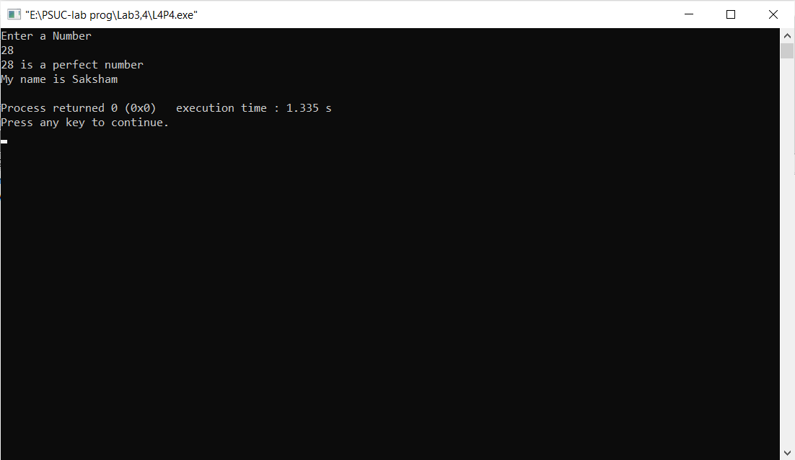

Q5) Find out the generic root of any number.

Code:

#include<stdio.h>

void main()

{

int num , digit ,c, sum=0;

printf("enter a positive number\n");

scanf("%d",&num);

c=num;

while(1)

{

sum=0;

while(num>0)

{

digit=num%10;

sum+=digit;

num=num/10;

}

if (sum>9)

{

num = sum;

}

else

break;

}

printf("the generic root of %d is %d\n",c,sum);

printf("My name is Saksham");

return 0;

}

Output:

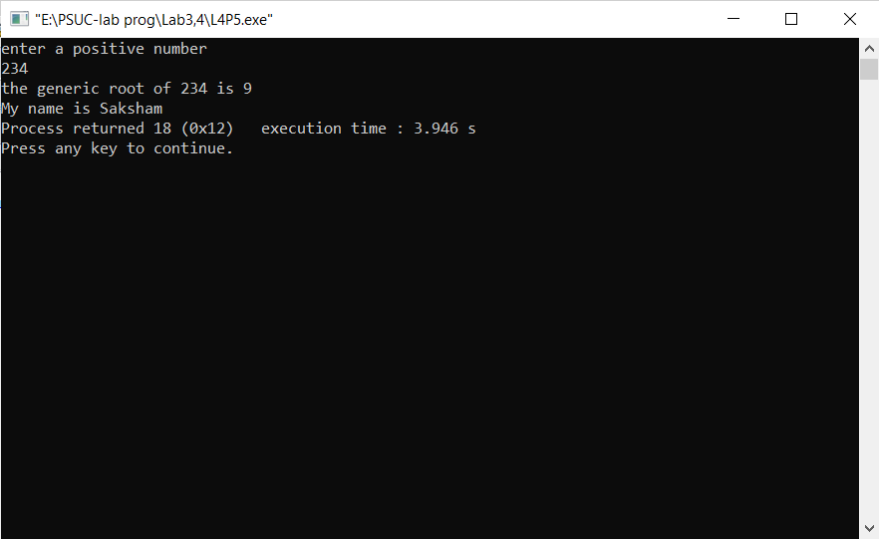

**Q6**) Write a program to demonstrate use of break and continue statements in for loop.

**Code**:

#include <stdio.h>

int main()

{

int i = 0, j = 0;

for (int i = 0; i <11 ; i++)

{

printf("i = %d, j =0 ",i);

for (j=0; j < i+1; j++)

{

if (j%2==0)

continue;

printf("%d ", j);

}

if (j==10)

break;

printf("\n");

}

printf("\nMy name is Saksham");

return 0;

}

**Output**:

